**GLOBAL FOOD PRODUCTION (1961 – 2023)**

**Introduction :**

The document "Global Food Production Trends (1961-2023)" analyzes historical data on food production worldwide, examining trends in agricultural output, major crop yields, and regional production patterns.

This analysis utilizes **Power BI** to visualize data across different time periods, continents, and economic classifications. The report highlights key factors influencing food production, such as technological advancements, climate change, and economic policies.

**Scenario 1: Food Production Trends by Region**

* The analysis shows that **Asia and North America** have the highest food production volumes, while **Africa and some parts of Latin America** experience fluctuations due to environmental and economic factors.
* Technological improvements and irrigation systems significantly impact production trends in high-yield regions.
* Climate variability plays a crucial role in food security, affecting crop yields across different regions.

**Scenario 2: Major Crop Yields Over Time**

* The dataset includes information on staple crops such as **wheat, rice, maize, and soybeans** over six decades.
* **Rice production** is highest in **Asia**, particularly in India and China.
* **Wheat and maize production** is led by **North America, Europe, and South America**, showing a steady increase due to improved agricultural techniques.
* Climate change and soil degradation have caused fluctuations in **African** and **Middle Eastern** crop yields.

**Scenario 3: Impact of Economic and Technological Growth**

* The dataset includes agricultural production categorized by **income classification** (low, middle, and high-income countries).
* **High-income countries** use advanced farming technology, leading to higher per-hectare yields.
* **Middle-income countries** show rapid growth due to increased investment in agricultural infrastructure.
* **Low-income countries** struggle with food security due to limited access to resources and modern farming techniques

**Technical Architecture:**

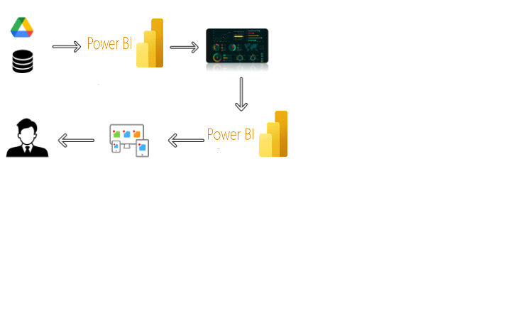

**Project Flow :**

To achieve this, we complete the following steps:

1. **Data Collection & Extraction from Database**
   * Gather food production datasets from global sources.
   * Store data in a structured **SQL database**.
2. **Data Preparation**
   * Clean and preprocess data for analysis.
   * Handle missing values and inconsistencies.
3. **Data Visualization in Power BI**
   * Create multiple charts and dashboards for insight generation.
4. **Dashboard Development**
   * Design an interactive and responsive Power BI dashboard.
5. **Report Generation**
   * Document key findings with structured storytelling.
6. **Performance Testing**
   * Assess the responsiveness and efficiency of data queries.
7. **Project Demonstration & Documentation**
   * Record a video explaining the project workflow.
   * Prepare step-by-step documentation.

**Milestone 1: Data Collection & Extraction from Database**

**Activity 1: Collect the dataset**

The dataset contains global food production data from 1961 to 2023, including:

* **Country** – Name of the country.
* **Year** – The year of data collection.
* **Crop Type** – Major food crops produced.
* **Production Volume** – Quantity of food produced (in metric tons).
* **Land Area Used** – Area used for food production (in hectares).
* **Yield per Hectare** – Productivity measure (metric tons per hectare).
* **Climate Impact Factors** – Temperature, rainfall, and drought data.

**Activity 2: Connect Data with Power BI**

* Establish a **SQL connection** in Power BI.
* Load and transform data for visualization.
* Ensure real-time updates where applicable.

**Milestone 2: Data Preparation**

**Activity 1: Clean and Prepare Data for Visualization**

* Remove missing or inconsistent records.
* Standardize units across different datasets.
* Convert categorical data into meaningful classifications.

**Milestone 3: Data Visualization**

**Activity 1: Number of Unique Visualizations**

* **Bar Charts** – Compare crop production across countries.
* **Line Graphs** – Show historical trends in food production.
* **Heat Maps** – Identify regions with high and low production levels.
* **Scatter Plots** – Correlate production trends with climate variables.
* **Pie Charts** – Show the proportion of global food production by region.

**Key Visualizations:**

1. Total Global Food Production Over Time
2. Comparison of Crop Production Across Continents
3. Impact of Climate Change on Agricultural Yields
4. Income Classification vs. Food Production Trends
5. Most Productive Countries by Crop Type

**Activity 1.1: Sum of Rice Production (tonnes)**

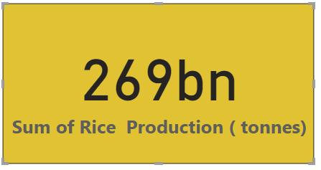

**Activity 1.2: Sum of Wheat Production (tonnes)**

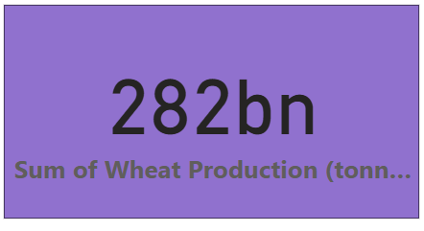

**Activity 1.3: Sum of Tea Production (tonnes)**

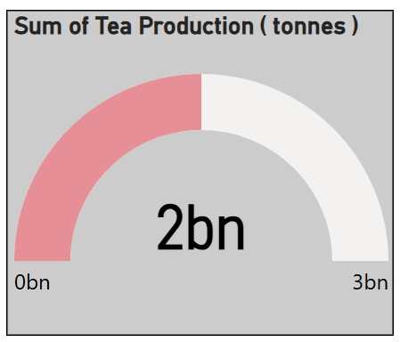

**Activity 1.4: Sum of Coffee,Green Production (tonnes) by Entity**

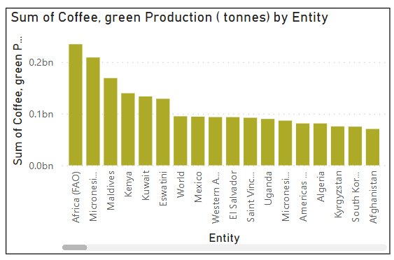

**Activity 1.5: Sum of Apples, Avacados,Bananas and Oranges (tonnes) by Entity**

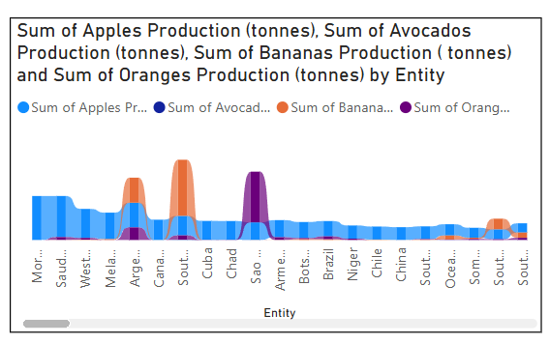

**Activity 1.6: Sum of MaizeProduction,Rice Production,Wheat Production by Year**

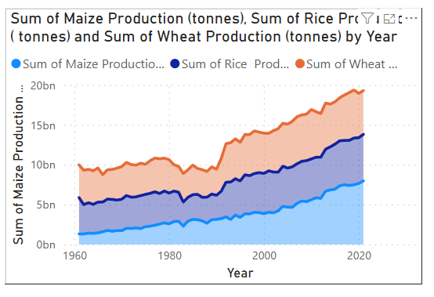

**Activity 1.7: Sum of Maize Production (tonnes) by YearGroup**

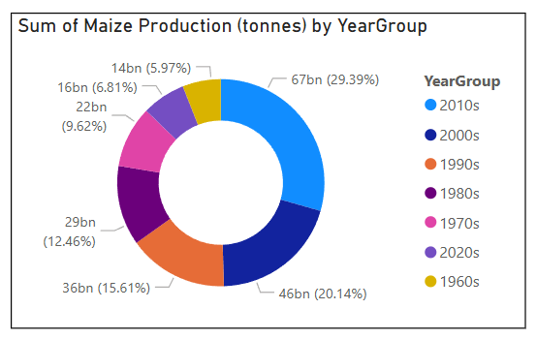

**Activity 1.7: Sum of Grapes,Apples,Bananas,Oranges production (tonnes)**

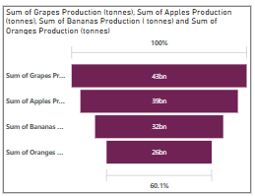

**Milestone 5: Dashboard**

* The dashboard presents **real-time insights** into food production trends.
* Users can filter data by **country, crop type, and time period**.
* It provides **aerial and geographic views** of food production hotspots.

**Activity :1- Responsive and Design of Dashboard**

A dashboard is a graphical user interface (GUI) that displays information and data in an organized, easy-to-read format. Dashboards are often used to provide real-time monitoring and analysis of data and are typically designed for a specific purpose or use case.

Dashboards can be used in a variety of settings, such as business, finance, manufacturing, healthcare, and many other industries. They can be used to track key performance indicators (KPIs), monitor performance metrics, and display data in the form of charts, graphs, and tables.

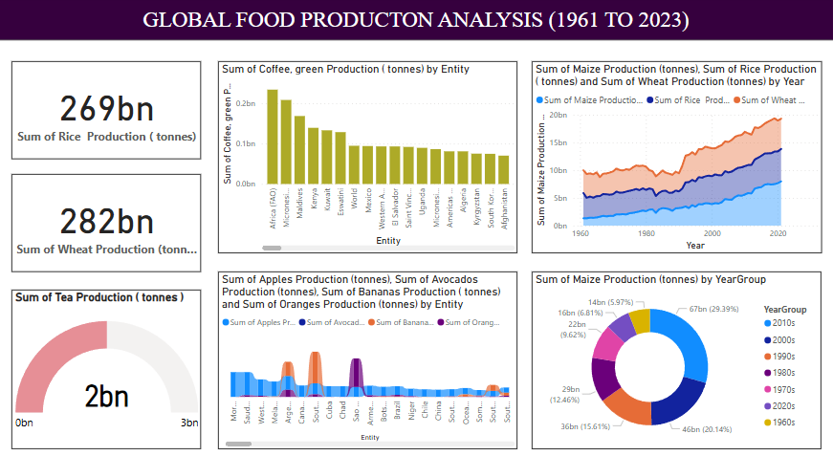

**Milestone 6: Report**

A data report is a way of presenting data and analysis in a narrative format, with the goal of making the information more engaging and easier to understand. A data story typically includes a clear introduction that sets the stage and explains the context for the data, a body that presents the data and analysis in a logical and systematic way, and a conclusion that summarizes the key findings and highlights their implications. Data Report can be told using a variety of mediums, presentations, interactive visualizations, and videos.

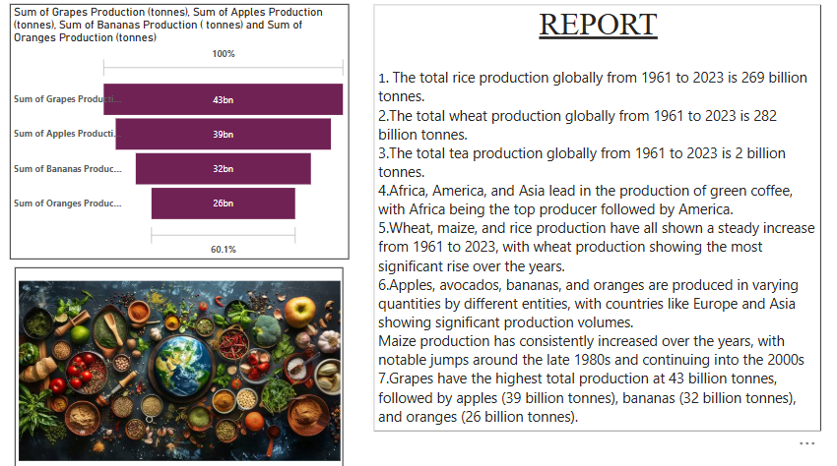

**Milestone 7: Performance Testing**

**Activity 1: Assess Data Load and Query Efficiency**

* Measure the **amount of data loaded into Power BI**.
* Optimize **database queries** for faster performance.
* Ensure **smooth navigation** across large datasets.

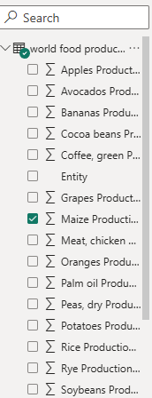

**Activity 2 : No of Visualizations/ Graphs**

* Sum of Rice Production (tonnes)
* Sum of Wheat Production (tonnes)
* Sum of Tea Production (tonnes)
* Sum of Coffee, Green Production (tonnes) by Entity
* Sum of Wheat Production (tonnes), Maize Production (tonnes), Rice Production (tonnes) by Year
* Sum of Apples, Avocados, Bananas, Oranges Production (tonnes) by Entity
* Sum of Maize Production (tonnes) by Year
* Sum of Grapes, Apples, Bananas, Oranges Production (tonnes)  
    
  **Activity 2.1: Utilization of Filters**

"Utilization of Filters" refers to the application or use of filters within a system, software application, or data processing pipeline to selectively extract, manipulate, or analyze data based on specified criteria or conditions.

**Selected “Entity (Country)” as a Filter**

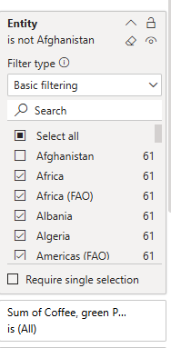

**Milestone 8: Project Demonstration & Documentation**

Below mentioned deliverables to be submitted along with other deliverables

**Activity 1:- Record explanation Video for project end to end solution**

This video serves as a comprehensive guide, detailing every aspect of the project from inception to completion.

https://drive.google.com/drive/folders/18xJVtAPNQHLo6YYZNMcuyWT3WSgW2BRf?usp=sharing

**Activity 2:- Project Documentation-Step by step project development procedure**

Create document as per the template provided